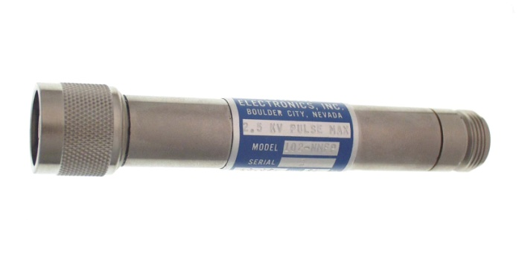

ADVANTAGES
- High voltage pulse rated
- Least expensive high voltage coaxial attenuator
available
- Small dimensions
Model 102-NMFP-20
- Higher average power than 142 series

DESCRIPTION

This unit utilizes a patented design, which provides for maintaining good HV capabilities and good
power dissipation. While this unit has a simpler housing design than our precision attenuators, for
better heat dissipation, it still provides a very respectable and clean 50 ps output risetime.

SPECIFICATIONS

Voltage Ratio: 10.0/1 Vr (20dB)

Maximum Input: 5.0kV, 80ns FWHM Pulse, 500kW Peak Power**
2.5kV, 400ns FWHM Pulse, 125kW Peak Power
1.25kV, 1600ns FWHM Pulse, 31kW Peak Power

Average Input Power: 5W maximum
10W with optional fins (Model CF) for external cooling

Impedance: 50 Ω ± 1%

Risetime through Unit: < 50ps

Bandwidth (-3dB): DC to 7GHz

Reflection-TDR: < 4% to a 100ps risetime step function

SWR: < 1.05 to 1GHz
< 1.30 to 4GHz
Voltage Coefficient: < 1% at rated voltage

Connectors: 102-NMFP-20 N Male/Female**
102-GLP-20 GR 874 locking
102-GP-20 GR 874 non-locking

Dimensions: 102-NMFP-20 5” long x .8” dia.
102-GP-20 4.5” long x 0.625" dia.
102-GLP-20 4.5” long x 1.01” dia.

Weight: 3/8 lb.

** Units with N connectors are limited to a 4kV rating.

ZAPLESS ®

